

**NET320-Database Systems**

**SWS213-Database Design**

**Spring ‘18**

**Lab 5- Relationship between tables**

*CLO1 Define core relational database concepts*

**Name:**

**ID:**

**Objective of the Lab**

Upon successful completion of this lab the student will be able to:

* Understand one to one relationship.
* Primary key
* Queries

**One to One Relationships**

When creating a database, we use separate tables for different types of entities. Some examples are: StudentsNames, Departments, ID, Location etc… But we also need to have relationships between these tables.

There are several types of database relationships.

Todays’ lab we are covering

One to One Relationships

**Lab Scenario**

Creating a Schema called CUDSWS.

Creating 2 tables called StudentNames and Departments.

Making a foreign key to access to Departments from StudentNames.

Using various queries.

1. Create a model named ‘CUDSWS’

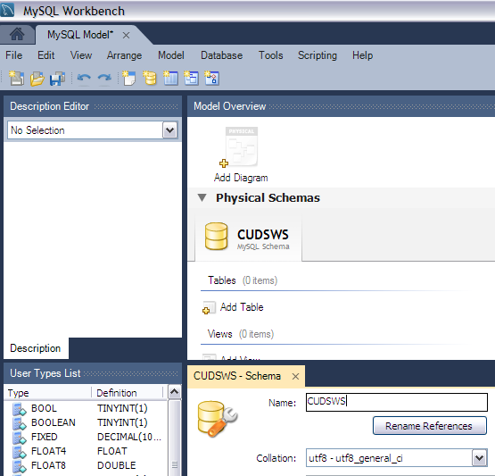

1. Create a table and name it as ‘StudentNames’.

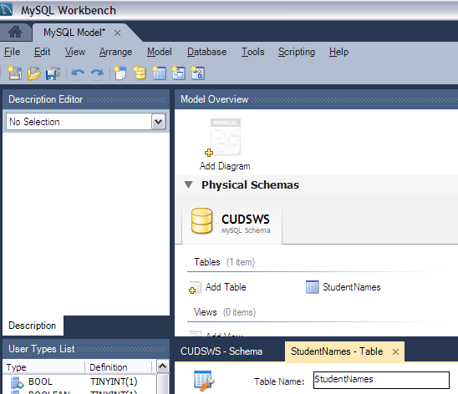

1. Fill the Column Names with StudentID, FirstName, SecondName and Dept_ID.

Make sure, you are assigning a primary key for StudentID. The Dept_ID’s datatype should be Integer.

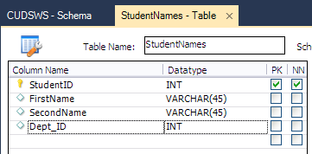

1. Create another table by double clicking ‘Add table’.

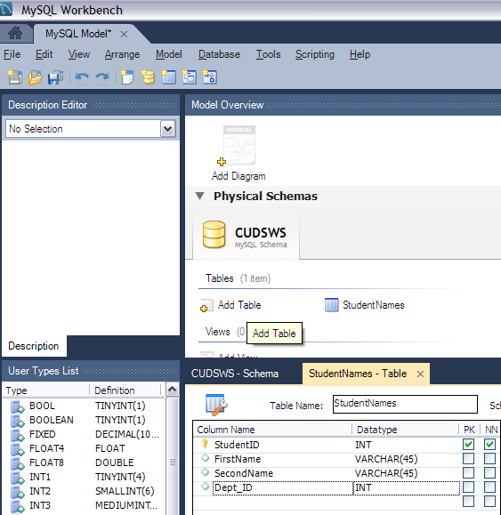

1. Enter the second table name as ‘Departments’.

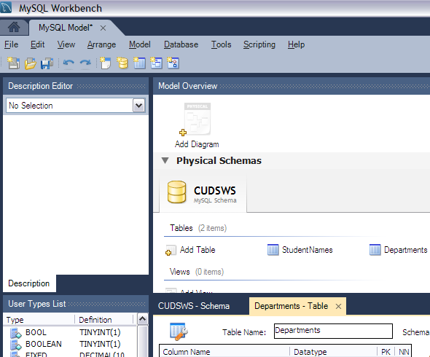

1. Fill in the column names as Dept_ID and Department_Name.

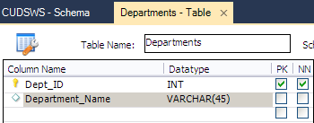

1. From Menu Save Model as ‘CUDStudents’

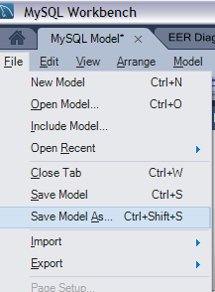

1. From the Database, Click on Forward Engineer.

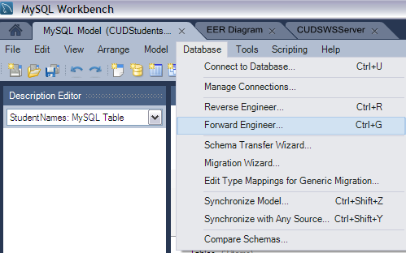

1. Create an EER diagram

For creating an EER diagram- Menu, Model, Create diagram from Catalog Objects.

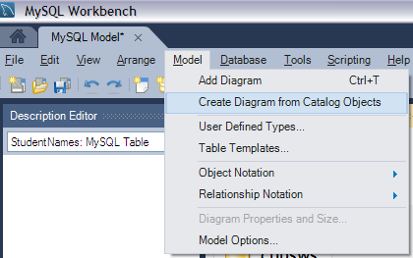

1. Your EER diagram should look like this.

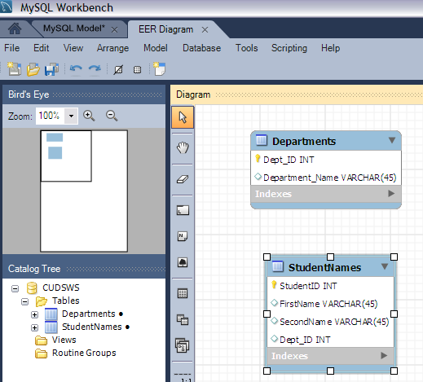

1. Now you have to create a database server.

For creating a database server, you have to click on Manage Connections from Database Menu.

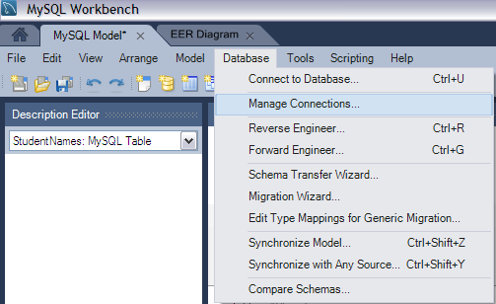

1. Click on New and give the connection name as ‘CUDSWSServer’.

Test the connection and click on ‘OK’.

1. From the MySQL Home Menu, double click on ‘CUDSWSServer’. If prompted for a password, enter password.

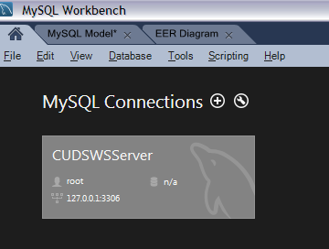

1. Expand tables departments and studentnames.
2. For expanding tables departments and studentnames, click on cudsws, then on tables and then on departments and studentnames respectively.

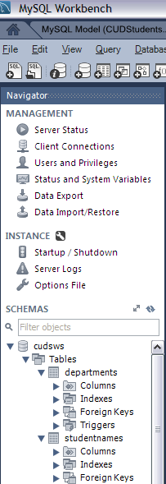

1. Right click on departments and select ‘Select Rows- Limit 1000’.

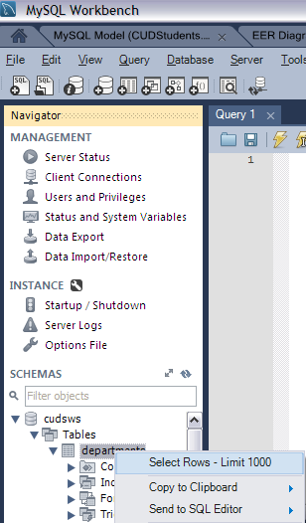

1. Right click on studentnames and select ‘Select Rows- Limit 1000’.

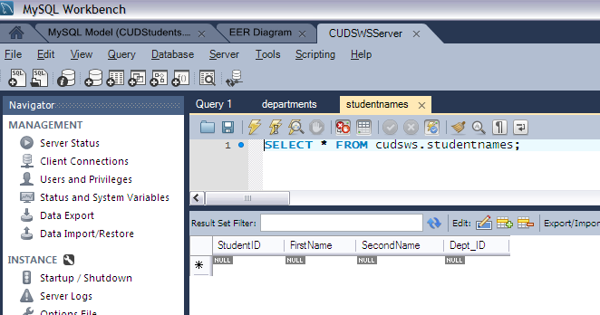

1. Select the departments and enter the details as below and click on apply.

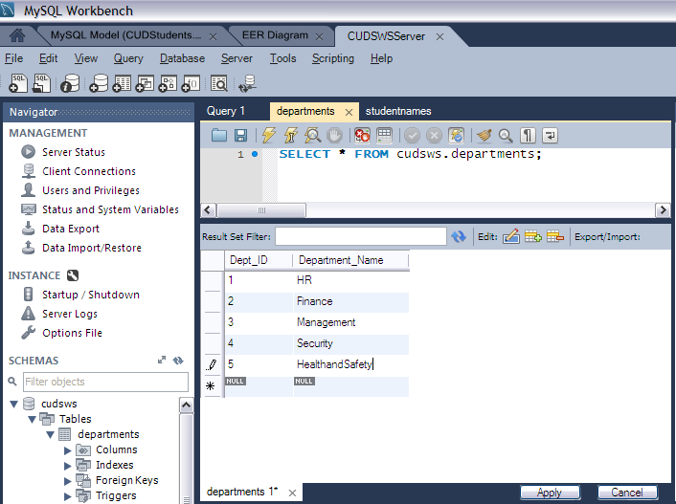

1. Select the student names and enter the details as below and click on apply.

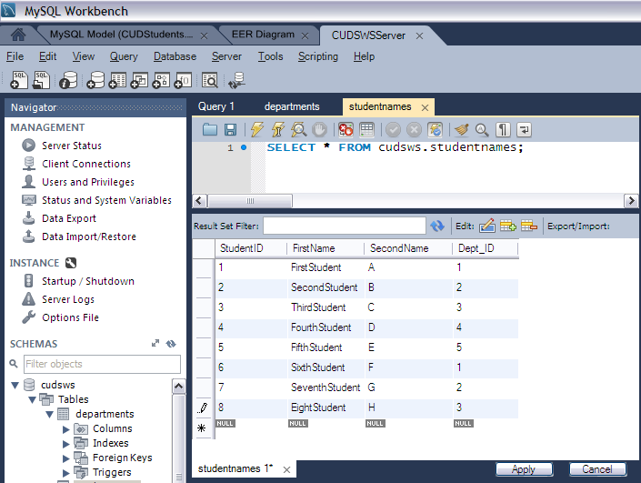

1. Right on ‘departments’ and click on ‘alter table’.

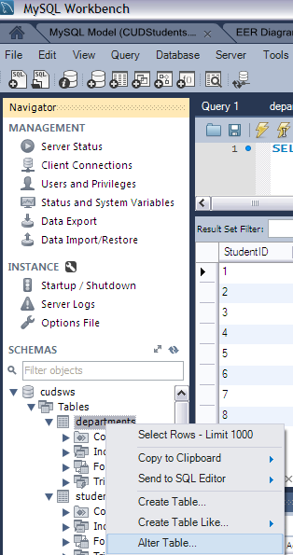

1. Right on ‘studentsname’ and click on ‘alter table’.
2. Now you have to assign a foreign key for relationship.

Select the studentsname table and click on foreign key.

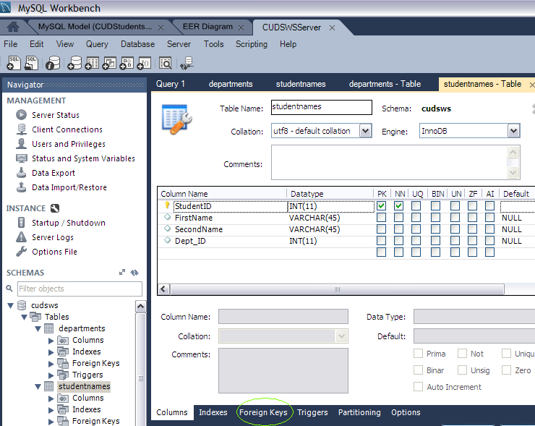

1. Enter ‘Dept’ under Foreign key name and select ‘cudsws’’departments’ under Referenced Table.

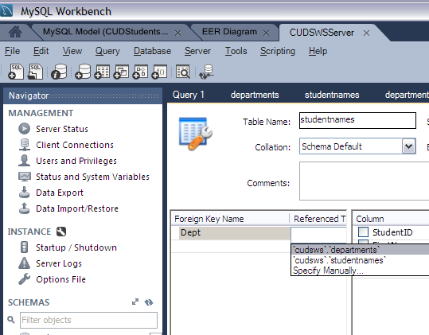

1. Under Column Select ‘Dept_ID and also Referenced Column as ‘Dept_ID’.

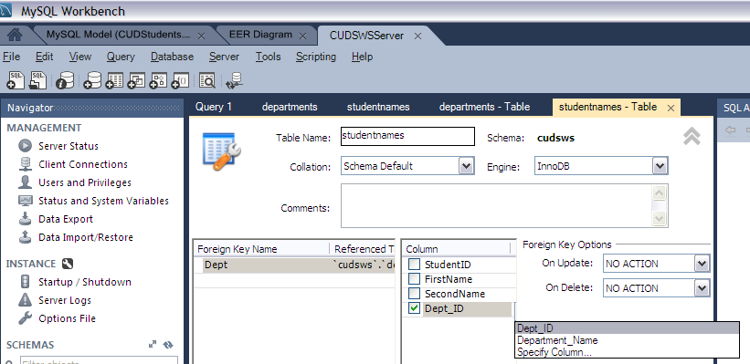

1. Click on ‘Apply’ and ‘Finish’.
2. Now apply the query

*SELECT * FROM cudsws.departments, cudsws.studentnames*

*where departments.Dept_ID = studentnames.Dept_ID;*

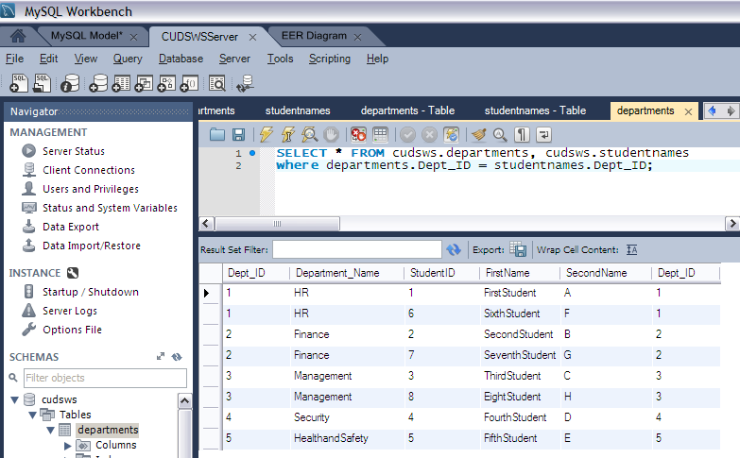

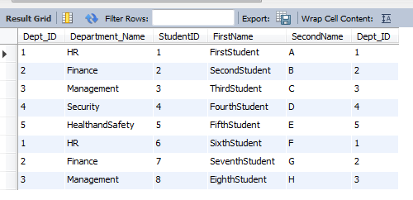

1. Try the below queries and observe the result.
2. *SELECT StudentID, FirstName, Department_Name FROM cudsws.departments, cudsws.studentnames*

*where departments.Dept_ID = studentnames.Dept_ID;*

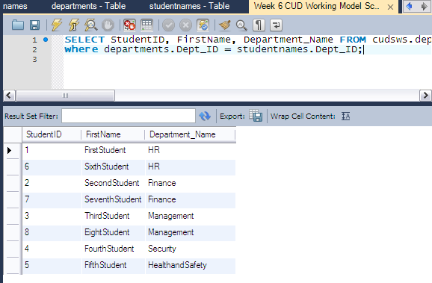

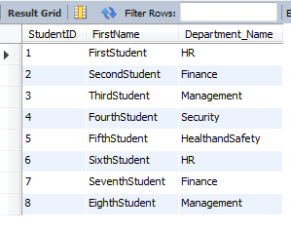

1. SELECT StudentID, FirstName, Department_Name FROM cudsws.departments, cudsws.studentnames

where departments.Dept_ID = studentnames.Dept_ID

and Department_Name='HR';

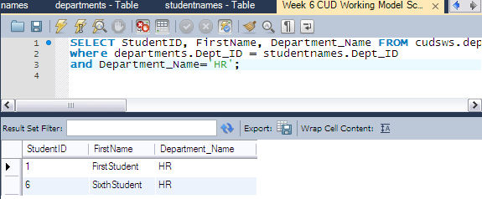

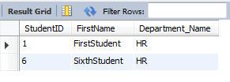

1. What is the query to display only students names in Management department?
2. Ans:- SELECT FirstName FROM cudsws.departments, cudsws.studentnames

where departments.Dept_ID = studentnames.Dept_ID

and Department_Name='Management';

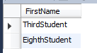

1. What is the query to display only students names and their department in Management department?
2. Ans:- SELECT FirstName, Department_Name FROM cudsws.departments, cudsws.studentnames

where departments.Dept_ID = studentnames.Dept_ID

and Department_Name='Management';

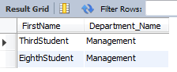

1. What is the query to display all student names and their departments?

Ans:- SELECT FirstName, Department_Name FROM cudsws.departments, cudsws.studentnames

where departments.Dept_ID = studentnames.Dept_ID;

